Dr. H N National College of Engineering
(Affiliated to VTU, Belagavi, Approved by AICTE, New Delhi and Govt. of Karnataka) 36B Cross, Jayanagar 7th block, Bengaluru – 560070

Department of ISE


Fourth Year
A Mini-Project Report On

“BILLING APPLICATION”
Submitted in the fulfilment of the requirements for
ADVANCED JAVA (BIS402)

SUBMITTED BY :

HAADI MOHAMMED OWAIS | 1HC24IS010
MOHAMMED AASHIR  KEDARLING | 1HC24IS023  1HC24IS017

IVth SEMESTER
Under the Guidance of
Dr Nandita Y Associate Professor

DEPT. OF INFORMATION SCIENCE AND ENGINEERING
Dr. H N National College of Engineering
(Affiliated to VTU, Belagavi, Approved by AICTE, New Delhi and Govt. of Karnataka) 36B Cross, Jayanagar 7th block, Bengaluru – 560070

Department of ISE
2025-2026

Certificate
This is to certify that the Mini Project Work entitled “BILLING APPLICATION” is a bonafide work carried out by HAADI MOHAMMED OWAIS (1HC24IS010), MOHAMMED AASHIR (1HC24IS023), KEDARLING (1HC24IS017) in partial fulfilment for the IV semester of Bachelor of Engineering in ISE of the Visvesvaraya Technological University, Belgaum during the year 2025-2026. The Project report has been approved as it satisfies the academics prescribed for the Bachelor of Engineering degree.

Signature of Guide | Signature of HOD
Dr Nandita Y | Dr Purushotham.U

TABLE OF CONTENTS

CHAPTERS:- | PAGE NO:-
1.INTRODUCTION | 4
2.PROBLEM DESCRIPTION | 6
3. HIGH LEVEL DESIGN | 7
4. CODE | 10
5. RESULT | 39
6.CONCLUSION | 40

CHAPTER -1

INTRODUCTION

WHAT IS INVENTORY MANAGEMENT SYSTEM ?

At its core, a billing application is a software tool designed to automate and streamline the process of invoicing customers, tracking sales, and managing payments. Based on the project details provided, here is a breakdown of what a billing application is and what it does:

It is a software system (in this case, a Java-based desktop application) specifically built for managing billing and invoicing in shops and businesses.

It serves as a direct replacement for manual billing, which is often slow and prone to human error

Key Features of a Banking Management System
• Invoicing: It allows for fast bill generation and accurate price calculations (including taxes and discounts).
• Inventory Management: It provides real-time stock tracking, automatically updating inventory counts as items are sold.
• Record Keeping: It maintains customer records, purchase histories, and generates printed receipts or PDF exports.
• Business Analytics: It generates daily and monthly sales reports to provide valuable insights into business performance.
Who Uses It?
- The system is designed for shop owners, supermarkets, medical stores, and essentially any retail business that requires quick and reliable invoicing solutions.
Advantages of Billing Project
Here are the main advantages of the Smart Billing System:
- Increased Speed and Efficiency: The system automates manual billing, saving time and reducing mistakes. It results in 80% faster billing and allows for fast bill generation.
- Complete Accuracy: It eliminates calculation errors entirely. The application consistently generates accurate bills with the correct totals, GST, and configured discounts applied.
- Real-Time Inventory Control: The application provides 100% real-time stock tracking. When a product is billed, the stock count is automatically reduced, which actively prevents overselling.
- Enhanced Customer Management: Customer details and purchase histories are stored securely and remain easily searchable by name or phone number.
- Valuable Business Insights: The system generates daily and monthly sales reports to provide shop owners with actionable business insights.
- Convenient Invoicing: Invoices can be directly printed or exported as PDFs for digital sharing. Fast bill generation, inventory tracking, and printed receipts are all managed in one place.
- Strong Security: The system protects sensitive business data using password encryption and role-based access for admins and staff.
- User-Friendly Design: It is built to be an easy-to-use application that retail staff can operate h minimal training.
CHAPTER-2

PROBLEM DESCRIPTION
The Smart Billing System implemented in Advanced Java is a comprehensive desktop application designed to automate real-world retail invoicing and shop management operations. It addresses critical business challenges associated with traditional, manual billing methods such as slow checkout speeds , human calculation errors , lack of real-time inventory tracking , and difficult-to-manage paper records.
The system allows businesses to:
- Manage Products and Customers: Create detailed records for retail items using categories and barcode support , while simultaneously maintaining customer profiles, purchase histories, and loyalty points.
- Process Billing Operations: Perform essential transactions rapidly through automatic price calculation, automated GST/Tax inclusion, discount handling, and real-time stock reduction upon sale.
- Support Advanced Functions: Features include triggering low stock alerts , generating daily and monthly sales reports , providing visual charts, and exporting invoices directly to printable PDFs or Excel files.
The application is built using object-oriented design principles and the MVC (Model-View-Controller) architecture pattern , ensuring modularity and maintainability across its Database, Service, and UI layers. The Java Swing-based interface mimics a modern retail checkout terminal, allowing cashiers and admins to perform operations quickly and reliably in real time. Each operation is rigorously validated—preventing errors such as miscalculating totals, applying incorrect taxes, or overselling out-of-stock items —thereby ensuring absolute financial accuracy and data integrity throughout the business.

CHAPTER-3

HIGH LEVEL DESIGN
1. Presentation Layer (User Interface)
- Technology: Java Swing and JavaFX. (Using components like JFrame, JPanel, JTextField, JButton, JTable, etc.).
- Responsibilities: Provides a user-friendly, rich desktop GUI tailored for cashiers, admins, and retail staff to input product data, process customer bills rapidly, and view real-time stock status.
2. Architecture and Modularity (Object-Oriented Principles) The system is built on the robust MVC (Model-View-Controller) architecture pattern. By utilizing an object-oriented approach, the application separates concerns into distinct layers:
- Model (Database): Uses JDBC to manage data storage in MySQL.
- View (UI): The Java Swing forms that the user interacts with.
- Controller (Services): Dedicated Core Java classes that handle business logic, ensuring that different modules (like User Authentication, Billing, and Inventory) operate independently. This guarantees that adding a new discount feature won't break the inventory tracking system.
3. Core Functionalities Mapped
Based on your project's detailed design, here are the core functionalities mapped to their specific modules:
- Billing & Invoicing Flow: Handles automatic price calculation, applies GST/Taxes, manages discounts, and allows for printing or exporting bills as PDFs.
- Inventory Control: Automatically reduces stock counts in real-time when an item is billed, provides low stock alerts, and manages product categories and barcodes.
- Customer Management: Maintains customer profiles, tracks purchase histories, and manages loyalty points for returning shoppers.
- Analytics & Reporting: Generates daily and monthly sales reports, outputting data into visual charts and Excel exports for business insights.
- Security & Access: Manages Admin and Staff roles securely using session management and password encryption (hashing).
.

Core Functionalities Mapped:
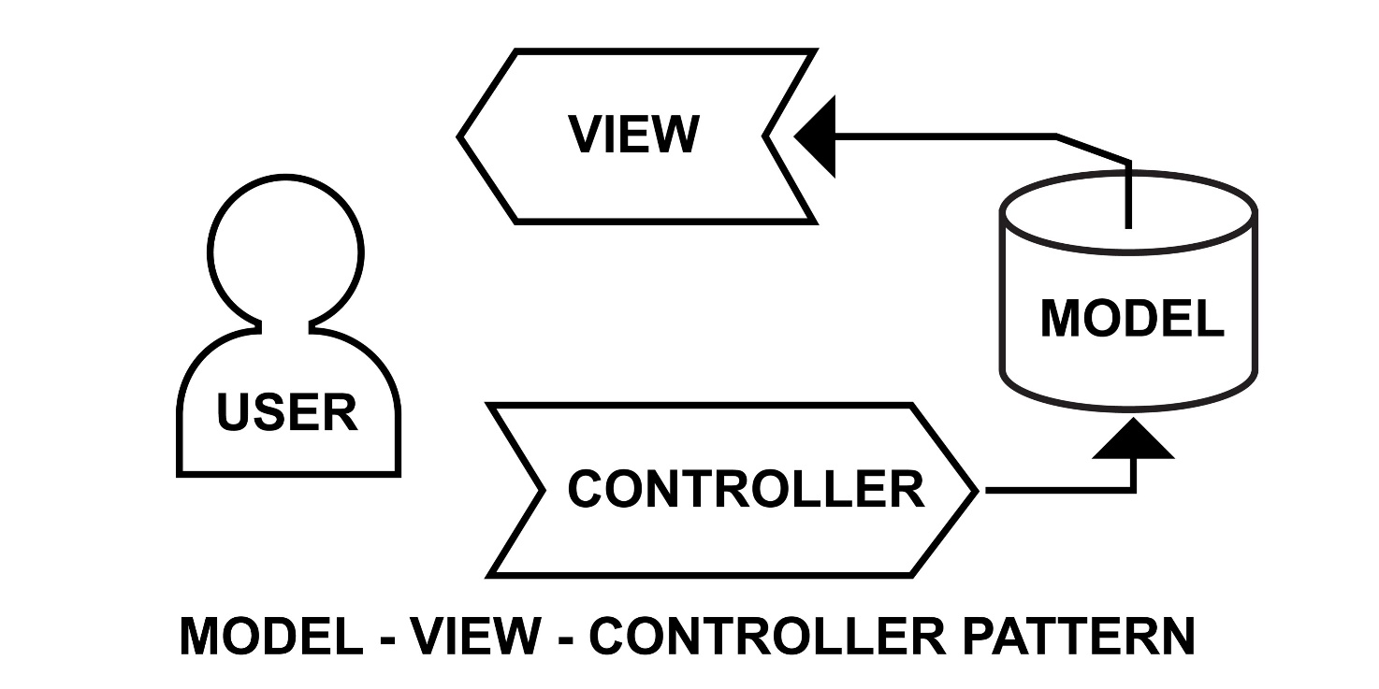

Advanced Java Features Utilized
- Cross-Platform Support: Allows deployment on any OS with a JVM (such as Windows 10/11 or Linux ), making it usable across various retail checkout terminals and back-office PCs.
- Real-Time Processing: Stock levels are updated instantly in the database upon confirmation of any billing transaction. When a product is billed, the stock count reduces automatically in real-time, ensuring accurate inventory counts immediately and actively preventing overselling.
- Data Structures & Collections: Used efficiently within the core Java services to manage complex relationships between product categories, customer profiles, and purchase histories simultaneously.

package javatosql;
CHAPTER-4

CODE

init.sql
-- Initialize database schema
USE billing_app;

-- Table for storing bills
CREATE TABLE IF NOT EXISTS bills (
bill_id INT PRIMARY KEY AUTO_INCREMENT,
customer_name VARCHAR(100) NOT NULL,
customer_phone VARCHAR(15),
bill_date TIMESTAMP DEFAULT CURRENT_TIMESTAMP,
total_amount DECIMAL(10, 2) NOT NULL,
discount_percent DECIMAL(5, 2) DEFAULT 0,
final_amount DECIMAL(10, 2) NOT NULL
);

-- Table for storing bill items
CREATE TABLE IF NOT EXISTS bill_items (
item_id INT PRIMARY KEY AUTO_INCREMENT,
bill_id INT NOT NULL,
item_name VARCHAR(100) NOT NULL,
quantity INT NOT NULL,
price DECIMAL(10, 2) NOT NULL,
item_total DECIMAL(10, 2) NOT NULL,
);

-- Sample data
INSERT INTO bills (customer_name, customer_phone, total_amount, discount_percent, final_amount) VALUES
('John Doe', '9876543210', 500.00, 10, 450.00),
('Jane Smith', '9876543211', 750.00, 5, 712.50);

INSERT INTO bill_items (bill_id, item_name, quantity, price, item_total) VALUES
(1, 'Notebook', 5, 50.00, 250.00),
(1, 'Pen Set', 2, 125.00, 250.00),
(2, 'Calculator', 1, 500.00, 500.00),
(2, 'Geometry Box', 1, 250.00, 250.00);

BillingDAO.java

// ====================================================================================
// FILE 4: src/dao/BillingDAO.java
// ====================================================================================

package dao;

import database.DatabaseConnection;
import models.Bill;
import models.BillItem;

import java.sql.*;
import java.util.ArrayList;
import java.util.List;

/**
* Data Access Object for billing operations
*/
public class BillingDAO {

/**
* Save a new bill to database
*/
public boolean saveBill(Bill bill) {
Connection conn = null;
PreparedStatement billStmt = null;
PreparedStatement itemStmt = null;
ResultSet rs = null;

try {
conn = DatabaseConnection.getConnection();
conn.setAutoCommit(false); // Start transaction

// Insert bill
String billSQL = "INSERT INTO bills (customer_name, customer_phone, total_amount, " +
"discount_percent, final_amount) VALUES (?, ?, ?, ?, ?)";
billStmt = conn.prepareStatement(billSQL, Statement.RETURN_GENERATED_KEYS);
billStmt.setString(1, bill.getCustomerName());
billStmt.setString(2, bill.getCustomerPhone());
billStmt.setDouble(3, bill.getTotalAmount());
billStmt.setDouble(4, bill.getDiscountPercent());
billStmt.setDouble(5, bill.getFinalAmount());

billStmt.executeUpdate();

// Get generated bill ID
rs = billStmt.getGeneratedKeys();
if (rs.next()) {
int billId = rs.getInt(1);
bill.setBillId(billId);

// Insert bill items
String itemSQL = "INSERT INTO bill_items (bill_id, item_name, quantity, " +
"price, item_total) VALUES (?, ?, ?, ?, ?)";
itemStmt = conn.prepareStatement(itemSQL);

for (BillItem item : bill.getItems()) {
itemStmt.setInt(1, billId);
itemStmt.setString(2, item.getItemName());
itemStmt.setInt(3, item.getQuantity());
itemStmt.setDouble(4, item.getPrice());
itemStmt.setDouble(5, item.getItemTotal());
itemStmt.addBatch();
}

itemStmt.executeBatch();
}

conn.commit(); // Commit transaction
return true;

} catch (SQLException e) {
if (conn != null) {
try {
conn.rollback(); // Rollback on error
} catch (SQLException ex) {
ex.printStackTrace();
}
}
e.printStackTrace();
return false;
} finally {
// Close resources
try {
if (rs != null) rs.close();
if (billStmt != null) billStmt.close();
if (itemStmt != null) itemStmt.close();
if (conn != null) conn.close();
} catch (SQLException e) {
e.printStackTrace();
}
}
}

/**
* Get all bills from database
*/
public List<Bill> getAllBills() {
List<Bill> bills = new ArrayList<>();
String sql = "SELECT * FROM bills ORDER BY bill_date DESC";

try (Connection conn = DatabaseConnection.getConnection();
Statement stmt = conn.createStatement();
ResultSet rs = stmt.executeQuery(sql)) {

while (rs.next()) {
Bill bill = new Bill();
bill.setBillId(rs.getInt("bill_id"));
bill.setCustomerName(rs.getString("customer_name"));
bill.setCustomerPhone(rs.getString("customer_phone"));
bill.setBillDate(rs.getTimestamp("bill_date"));
bill.setTotalAmount(rs.getDouble("total_amount"));
bill.setDiscountPercent(rs.getDouble("discount_percent"));
bill.setFinalAmount(rs.getDouble("final_amount"));
bills.add(bill);
}

} catch (SQLException e) {
e.printStackTrace();
}

return bills;
}

/**
* Get bill by ID with all items
*/
public Bill getBillById(int billId) {
Bill bill = null;
String billSQL = "SELECT * FROM bills WHERE bill_id = ?";
String itemsSQL = "SELECT * FROM bill_items WHERE bill_id = ?";

try (Connection conn = DatabaseConnection.getConnection();
PreparedStatement billStmt = conn.prepareStatement(billSQL);
PreparedStatement itemsStmt = conn.prepareStatement(itemsSQL)) {

// Get bill details
billStmt.setInt(1, billId);
ResultSet billRS = billStmt.executeQuery();

if (billRS.next()) {
bill = new Bill();
bill.setBillId(billRS.getInt("bill_id"));
bill.setCustomerName(billRS.getString("customer_name"));
bill.setCustomerPhone(billRS.getString("customer_phone"));
bill.setBillDate(billRS.getTimestamp("bill_date"));
bill.setTotalAmount(billRS.getDouble("total_amount"));
bill.setDiscountPercent(billRS.getDouble("discount_percent"));
bill.setFinalAmount(billRS.getDouble("final_amount"));

// Get bill items
itemsStmt.setInt(1, billId);
ResultSet itemsRS = itemsStmt.executeQuery();

while (itemsRS.next()) {
BillItem item = new BillItem();
item.setItemId(itemsRS.getInt("item_id"));
item.setBillId(itemsRS.getInt("bill_id"));
item.setItemName(itemsRS.getString("item_name"));
item.setQuantity(itemsRS.getInt("quantity"));
item.setPrice(itemsRS.getDouble("price"));
item.setItemTotal(itemsRS.getDouble("item_total"));
bill.addItem(item);
}

itemsRS.close();
}

billRS.close();

} catch (SQLException e) {
e.printStackTrace();
}

return bill;
}

/**
* Delete a bill by ID
*/
public boolean deleteBill(int billId) {
String sql = "DELETE FROM bills WHERE bill_id = ?";

try (Connection conn = DatabaseConnection.getConnection();
PreparedStatement stmt = conn.prepareStatement(sql)) {

stmt.setInt(1, billId);
int rows = stmt.executeUpdate();
return rows > 0;

} catch (SQLException e) {
e.printStackTrace();
return false;
}
}
}

DatabaseConnection.java

// ====================================================================================
// FILE 1: src/database/DatabaseConnection.java
// ====================================================================================

package database;

import java.sql.Connection;
import java.sql.DriverManager;
import java.sql.SQLException;

public class DatabaseConnection {

// For local MySQL on Windows
private static final String DB_HOST = System.getenv().getOrDefault("DB_HOST", "localhost");
private static final String DB_PORT = System.getenv().getOrDefault("DB_PORT", "3306");
private static final String DB_NAME = System.getenv().getOrDefault("DB_NAME", "billing_app");
private static final String DB_USER = System.getenv().getOrDefault("DB_USER", "root");
private static final String DB_PASSWORD = System.getenv().getOrDefault("DB_PASSWORD", "abc123");

private static final String URL = "jdbc:mysql://" + DB_HOST + ":" + DB_PORT + "/" + DB_NAME +
"?useSSL=false&allowPublicKeyRetrieval=true&serverTimezone=UTC";

public static Connection getConnection() throws SQLException {
try {
Class.forName("com.mysql.cj.jdbc.Driver");
return DriverManager.getConnection(URL, DB_USER, DB_PASSWORD);
} catch (ClassNotFoundException e) {
throw new SQLException("MySQL JDBC Driver not found", e);
}
}

public static boolean testConnection() {
int maxRetries = 5;
int retryCount = 0;

while (retryCount < maxRetries) {
try (Connection conn = getConnection()) {
return conn != null && !conn.isClosed();
} catch (SQLException e) {
retryCount++;
System.err.println("Database connection attempt " + retryCount + " failed: " + e.getMessage());
if (retryCount < maxRetries) {
try {
Thread.sleep(2000);
} catch (InterruptedException ie) {
Thread.currentThread().interrupt();
}
}
}
}
return false;
}
}

Bill.java

// ====================================================================================
// FILE 2: src/models/Bill.java
// ====================================================================================

package models;

import java.sql.Timestamp;
import java.util.ArrayList;
import java.util.List;

/**
* Represents a Bill with customer details and items
*/
public class Bill {
private int billId;
private String customerName;
private String customerPhone;
private Timestamp billDate;
private double totalAmount;
private double discountPercent;
private double finalAmount;
private List<BillItem> items;

public Bill() {
this.items = new ArrayList<>();
}

public Bill(String customerName, String customerPhone) {
this.customerName = customerName;
this.customerPhone = customerPhone;
this.items = new ArrayList<>();
this.discountPercent = 0;
}

// Add item to bill
public void addItem(BillItem item) {
items.add(item);
}

// Calculate total amount
public void calculateTotals() {
totalAmount = 0;
for (BillItem item : items) {
totalAmount += item.getItemTotal();
}

// Apply discount
double discountAmount = totalAmount * (discountPercent / 100);
finalAmount = totalAmount - discountAmount;
}

// Getters and Setters
public int getBillId() { return billId; }
public void setBillId(int billId) { this.billId = billId; }

public String getCustomerName() { return customerName; }
public void setCustomerName(String customerName) { this.customerName = customerName; }

public String getCustomerPhone() { return customerPhone; }
public void setCustomerPhone(String customerPhone) { this.customerPhone = customerPhone; }

public Timestamp getBillDate() { return billDate; }
public void setBillDate(Timestamp billDate) { this.billDate = billDate; }

public double getTotalAmount() { return totalAmount; }
public void setTotalAmount(double totalAmount) { this.totalAmount = totalAmount; }

public double getDiscountPercent() { return discountPercent; }
public void setDiscountPercent(double discountPercent) { this.discountPercent = discountPercent; }

public double getFinalAmount() { return finalAmount; }
public void setFinalAmount(double finalAmount) { this.finalAmount = finalAmount; }

public List<BillItem> getItems() { return items; }
public void setItems(List<BillItem> items) { this.items = items; }
}

BillItem.java

// ====================================================================================
// FILE 3: src/models/BillItem.java
// ====================================================================================

package models;

/**
* Represents a single item in a bill
*/
public class BillItem {
private int itemId;
private int billId;
private String itemName;
private int quantity;
private double price;
private double itemTotal;

public BillItem() {}

public BillItem(String itemName, int quantity, double price) {
this.itemName = itemName;
this.quantity = quantity;
this.price = price;
this.itemTotal = quantity * price;
}

// Calculate item total
public void calculateTotal() {
this.itemTotal = quantity * price;
}

// Getters and Setters
public int getItemId() { return itemId; }
public void setItemId(int itemId) { this.itemId = itemId; }

public int getBillId() { return billId; }
public void setBillId(int billId) { this.billId = billId; }

public String getItemName() { return itemName; }
public void setItemName(String itemName) { this.itemName = itemName; }

public int getQuantity() { return quantity; }
public void setQuantity(int quantity) {
this.quantity = quantity;
calculateTotal();
}

public double getPrice() { return price; }
public void setPrice(double price) {
this.price = price;
calculateTotal();
}

public double getItemTotal() { return itemTotal; }
public void setItemTotal(double itemTotal) { this.itemTotal = itemTotal; }
}

BillingApp.java

// ====================================================================================
// FILE 5: src/ui/BillingApp.java
// ====================================================================================

package ui;

import dao.BillingDAO;
import database.DatabaseConnection;
import models.Bill;
import models.BillItem;

import javax.swing.*;
import javax.swing.table.DefaultTableModel;
import java.awt.*;
import java.awt.event.*;
import java.util.ArrayList;
import java.util.List;

/**
* Java Swing GUI for Billing Application
*/
public class BillingApp extends JFrame {

private BillingDAO dao;
private JTabbedPane tabbedPane;

// Create Bill Tab Components
private JTextField customerNameField;
private JTextField customerPhoneField;
private JTextField itemNameField;
private JTextField quantityField;
private JTextField priceField;
private JTextField discountField;
private JTable itemsTable;
private DefaultTableModel itemsTableModel;
private JLabel totalLabel;
private JLabel discountAmountLabel;
private JLabel finalAmountLabel;
private List<BillItem> currentItems;

// View Bills Tab Components
private JTable billsTable;
private DefaultTableModel billsTableModel;

public BillingApp() {
dao = new BillingDAO();
currentItems = new ArrayList<>();

setTitle("Billing Application - Java Swing + MySQL");
setSize(950, 700);
setDefaultCloseOperation(JFrame.EXIT_ON_CLOSE);
setLocationRelativeTo(null);

// Test database connection
System.out.println("Testing database connection...");
if (!DatabaseConnection.testConnection()) {
JOptionPane.showMessageDialog(this,
"Failed to connect to database!\nPlease check database configuration.",
"Database Error",
JOptionPane.ERROR_MESSAGE);
System.exit(1);
}
System.out.println("Database connected successfully!");

initComponents();
setVisible(true);
}

private void initComponents() {
tabbedPane = new JTabbedPane();

// Add tabs
tabbedPane.addTab("📝 Create Bill", createBillPanel());
tabbedPane.addTab("📋 View Bills", createViewBillsPanel());
tabbedPane.addTab("ℹ️ About", createAboutPanel());

add(tabbedPane);
}

// ==================================================================================
// CREATE BILL PANEL
// ==================================================================================
private JPanel createBillPanel() {
JPanel mainPanel = new JPanel(new BorderLayout(10, 10));
mainPanel.setBorder(BorderFactory.createEmptyBorder(15, 15, 15, 15));

// Customer Details Panel
JPanel customerPanel = new JPanel(new GridBagLayout());
customerPanel.setBorder(BorderFactory.createTitledBorder(
BorderFactory.createLineBorder(Color.GRAY), "Customer Details"));
GridBagConstraints gbc = new GridBagConstraints();
gbc.fill = GridBagConstraints.HORIZONTAL;
gbc.insets = new Insets(8, 8, 8, 8);

gbc.gridx = 0; gbc.gridy = 0;
customerPanel.add(new JLabel("Customer Name:"), gbc);
gbc.gridx = 1; gbc.weightx = 1.0;
customerNameField = new JTextField(25);
customerNameField.setFont(new Font("Arial", Font.PLAIN, 14));
customerPanel.add(customerNameField, gbc);

gbc.gridx = 0; gbc.gridy = 1; gbc.weightx = 0;
customerPanel.add(new JLabel("Phone Number:"), gbc);
gbc.gridx = 1; gbc.weightx = 1.0;
customerPhoneField = new JTextField(25);
customerPhoneField.setFont(new Font("Arial", Font.PLAIN, 14));
customerPanel.add(customerPhoneField, gbc);

// Add Item Panel
JPanel addItemPanel = new JPanel(new GridBagLayout());
addItemPanel.setBorder(BorderFactory.createTitledBorder(
BorderFactory.createLineBorder(Color.GRAY), "Add Items to Bill"));
gbc = new GridBagConstraints();
gbc.fill = GridBagConstraints.HORIZONTAL;
gbc.insets = new Insets(8, 8, 8, 8);

gbc.gridx = 0; gbc.gridy = 0;
addItemPanel.add(new JLabel("Item Name:"), gbc);
gbc.gridx = 1; gbc.weightx = 1.0;
itemNameField = new JTextField(20);
itemNameField.setFont(new Font("Arial", Font.PLAIN, 14));
addItemPanel.add(itemNameField, gbc);

gbc.gridx = 2; gbc.weightx = 0;
addItemPanel.add(new JLabel("Qty:"), gbc);
gbc.gridx = 3; gbc.weightx = 0.3;
quantityField = new JTextField(8);
quantityField.setFont(new Font("Arial", Font.PLAIN, 14));
addItemPanel.add(quantityField, gbc);

gbc.gridx = 4; gbc.weightx = 0;
addItemPanel.add(new JLabel("Price:"), gbc);
gbc.gridx = 5; gbc.weightx = 0.3;
priceField = new JTextField(10);
priceField.setFont(new Font("Arial", Font.PLAIN, 14));
addItemPanel.add(priceField, gbc);

gbc.gridx = 6; gbc.weightx = 0;
JButton addButton = new JButton("➕ Add Item");
addButton.setFont(new Font("Arial", Font.BOLD, 13));
addButton.setBackground(new Color(34, 139, 34));
addButton.setForeground(Color.WHITE);
addButton.setFocusPainted(false);
addButton.addActionListener(e -> addItem());
addItemPanel.add(addButton, gbc);

// Items Table
String[] columns = {"Item Name", "Quantity", "Price (₹)", "Total (₹)"};
itemsTableModel = new DefaultTableModel(columns, 0) {
@Override
public boolean isCellEditable(int row, int column) {
return false;
}
};
itemsTable = new JTable(itemsTableModel);
itemsTable.setFont(new Font("Arial", Font.PLAIN, 13));
itemsTable.setRowHeight(25);
itemsTable.getTableHeader().setFont(new Font("Arial", Font.BOLD, 13));
JScrollPane tableScrollPane = new JScrollPane(itemsTable);
tableScrollPane.setPreferredSize(new Dimension(0, 220));

JPanel tablePanel = new JPanel(new BorderLayout());
tablePanel.setBorder(BorderFactory.createTitledBorder(
BorderFactory.createLineBorder(Color.GRAY), "Items in Current Bill"));
tablePanel.add(tableScrollPane, BorderLayout.CENTER);

JButton removeButton = new JButton("🗑️ Remove Selected");
removeButton.setFont(new Font("Arial", Font.PLAIN, 12));
removeButton.setBackground(new Color(220, 53, 69));
removeButton.setForeground(Color.WHITE);
removeButton.setFocusPainted(false);
removeButton.addActionListener(e -> removeSelectedItem());
JPanel tableButtonPanel = new JPanel(new FlowLayout(FlowLayout.RIGHT));
tableButtonPanel.add(removeButton);
tablePanel.add(tableButtonPanel, BorderLayout.SOUTH);

// Total Panel
JPanel totalPanel = new JPanel(new GridBagLayout());
totalPanel.setBorder(BorderFactory.createTitledBorder(
BorderFactory.createLineBorder(Color.GRAY), "Bill Summary"));
gbc = new GridBagConstraints();
gbc.fill = GridBagConstraints.HORIZONTAL;
gbc.insets = new Insets(8, 15, 8, 15);

gbc.gridx = 0; gbc.gridy = 0;
JLabel discLabel = new JLabel("Discount %:");
discLabel.setFont(new Font("Arial", Font.PLAIN, 14));
totalPanel.add(discLabel, gbc);

gbc.gridx = 1; gbc.weightx = 0.3;
discountField = new JTextField("0", 8);
discountField.setFont(new Font("Arial", Font.PLAIN, 14));
discountField.addKeyListener(new KeyAdapter() {
@Override
public void keyReleased(KeyEvent e) {
calculateTotals();
}
});
totalPanel.add(discountField, gbc);

gbc.gridx = 2; gbc.weightx = 0;
JLabel totLabel = new JLabel("Subtotal:");
totLabel.setFont(new Font("Arial", Font.BOLD, 14));
totalPanel.add(totLabel, gbc);

gbc.gridx = 3; gbc.weightx = 0.5;
totalLabel = new JLabel("₹0.00");
totalLabel.setFont(new Font("Arial", Font.BOLD, 16));
totalLabel.setForeground(new Color(0, 102, 204));
totalPanel.add(totalLabel, gbc);

gbc.gridx = 0; gbc.gridy = 1;
JLabel discAmtLabel = new JLabel("Discount Amount:");
discAmtLabel.setFont(new Font("Arial", Font.PLAIN, 14));
totalPanel.add(discAmtLabel, gbc);

gbc.gridx = 1;
discountAmountLabel = new JLabel("₹0.00");
discountAmountLabel.setFont(new Font("Arial", Font.PLAIN, 14));
discountAmountLabel.setForeground(new Color(220, 53, 69));
totalPanel.add(discountAmountLabel, gbc);

gbc.gridx = 2;
JLabel finalLabel = new JLabel("FINAL AMOUNT:");
finalLabel.setFont(new Font("Arial", Font.BOLD, 15));
totalPanel.add(finalLabel, gbc);

gbc.gridx = 3;
finalAmountLabel = new JLabel("₹0.00");
finalAmountLabel.setFont(new Font("Arial", Font.BOLD, 18));
finalAmountLabel.setForeground(new Color(0, 128, 0));
totalPanel.add(finalAmountLabel, gbc);

// Buttons Panel
JPanel buttonsPanel = new JPanel(new FlowLayout(FlowLayout.RIGHT, 15, 10));

JButton clearButton = new JButton("🔄 Clear All");
clearButton.setFont(new Font("Arial", Font.PLAIN, 14));
clearButton.setBackground(new Color(108, 117, 125));
clearButton.setForeground(Color.WHITE);
clearButton.setFocusPainted(false);
clearButton.addActionListener(e -> clearForm());

JButton saveBillButton = new JButton("💾 Save Bill");
saveBillButton.setFont(new Font("Arial", Font.BOLD, 15));
saveBillButton.setBackground(new Color(40, 167, 69));
saveBillButton.setForeground(Color.WHITE);
saveBillButton.setFocusPainted(false);
saveBillButton.setPreferredSize(new Dimension(140, 40));
saveBillButton.addActionListener(e -> saveBill());

buttonsPanel.add(clearButton);
buttonsPanel.add(saveBillButton);

// Layout
JPanel topPanel = new JPanel(new BorderLayout(10, 10));
topPanel.add(customerPanel, BorderLayout.NORTH);
topPanel.add(addItemPanel, BorderLayout.CENTER);

JPanel bottomPanel = new JPanel(new BorderLayout(10, 10));
bottomPanel.add(totalPanel, BorderLayout.NORTH);
bottomPanel.add(buttonsPanel, BorderLayout.SOUTH);

mainPanel.add(topPanel, BorderLayout.NORTH);
mainPanel.add(tablePanel, BorderLayout.CENTER);
mainPanel.add(bottomPanel, BorderLayout.SOUTH);

return mainPanel;
}

private void addItem() {
String itemName = itemNameField.getText().trim();
String quantityStr = quantityField.getText().trim();
String priceStr = priceField.getText().trim();

if (itemName.isEmpty() || quantityStr.isEmpty() || priceStr.isEmpty()) {
JOptionPane.showMessageDialog(this,
"Please fill all item fields!",
"Input Error",
JOptionPane.WARNING_MESSAGE);
return;
}

try {
int quantity = Integer.parseInt(quantityStr);
double price = Double.parseDouble(priceStr);

if (quantity <= 0 || price <= 0) {
JOptionPane.showMessageDialog(this,
"Quantity and price must be positive!",
"Input Error",
JOptionPane.WARNING_MESSAGE);
return;
}

BillItem item = new BillItem(itemName, quantity, price);
currentItems.add(item);

itemsTableModel.addRow(new Object[]{
item.getItemName(),
item.getQuantity(),
String.format("%.2f", item.getPrice()),
String.format("%.2f", item.getItemTotal())
});

// Clear fields
itemNameField.setText("");
quantityField.setText("");
priceField.setText("");
itemNameField.requestFocus();

calculateTotals();

} catch (NumberFormatException ex) {
JOptionPane.showMessageDialog(this,
"Invalid quantity or price format!",
"Input Error",
JOptionPane.ERROR_MESSAGE);
}
}

private void removeSelectedItem() {
int selectedRow = itemsTable.getSelectedRow();
if (selectedRow >= 0) {
currentItems.remove(selectedRow);
itemsTableModel.removeRow(selectedRow);
calculateTotals();
} else {
JOptionPane.showMessageDialog(this,
"Please select an item to remove!",
"Selection Error",
JOptionPane.WARNING_MESSAGE);
}
}

private void calculateTotals() {
double total = 0;
for (BillItem item : currentItems) {
total += item.getItemTotal();
}

double discountPercent = 0;
try {
discountPercent = Double.parseDouble(discountField.getText());
if (discountPercent < 0 || discountPercent > 100) {
discountPercent = 0;
discountField.setText("0");
}
} catch (NumberFormatException ex) {
discountPercent = 0;
discountField.setText("0");
}

double discountAmount = total * (discountPercent / 100);
double finalAmount = total - discountAmount;

totalLabel.setText(String.format("₹%.2f", total));
discountAmountLabel.setText(String.format("₹%.2f", discountAmount));
finalAmountLabel.setText(String.format("₹%.2f", finalAmount));
}

private void saveBill() {
String customerName = customerNameField.getText().trim();
String customerPhone = customerPhoneField.getText().trim();

if (customerName.isEmpty()) {
JOptionPane.showMessageDialog(this,
"Please enter customer name!",
"Input Error",
JOptionPane.WARNING_MESSAGE);
customerNameField.requestFocus();
return;
}

if (currentItems.isEmpty()) {
JOptionPane.showMessageDialog(this,
"Please add at least one item!",
"Input Error",
JOptionPane.WARNING_MESSAGE);
return;
}

Bill bill = new Bill(customerName, customerPhone);
for (BillItem item : currentItems) {
bill.addItem(item);
}

try {
double discountPercent = Double.parseDouble(discountField.getText());
bill.setDiscountPercent(discountPercent);
} catch (NumberFormatException ex) {
bill.setDiscountPercent(0);
}

bill.calculateTotals();

if (dao.saveBill(bill)) {
JOptionPane.showMessageDialog(this,
"✅ Bill saved successfully!\n\nBill ID: " + bill.getBillId() +
"\nCustomer: " + bill.getCustomerName() +
"\nFinal Amount: ₹" + String.format("%.2f", bill.getFinalAmount()),
"Success",
JOptionPane.INFORMATION_MESSAGE);
clearForm();
refreshBillsTable();
} else {
JOptionPane.showMessageDialog(this,
"❌ Failed to save bill!\nPlease check database connection.",
"Error",
JOptionPane.ERROR_MESSAGE);
}
}

private void clearForm() {
customerNameField.setText("");
customerPhoneField.setText("");
itemNameField.setText("");
quantityField.setText("");
priceField.setText("");
discountField.setText("0");
currentItems.clear();
itemsTableModel.setRowCount(0);
calculateTotals();
customerNameField.requestFocus();
}

// ==================================================================================
// VIEW BILLS PANEL
// ==================================================================================
private JPanel createViewBillsPanel() {
JPanel panel = new JPanel(new BorderLayout(10, 10));
panel.setBorder(BorderFactory.createEmptyBorder(15, 15, 15, 15));

// Bills Table
String[] columns = {"Bill ID", "Customer Name", "Phone", "Date & Time", "Total", "Discount", "Final Amount"};
billsTableModel = new DefaultTableModel(columns, 0) {
@Override
public boolean isCellEditable(int row, int column) {
return false;
}
};
billsTable = new JTable(billsTableModel);
billsTable.setFont(new Font("Arial", Font.PLAIN, 13));
billsTable.setRowHeight(28);
billsTable.getTableHeader().setFont(new Font("Arial", Font.BOLD, 13));
billsTable.setSelectionMode(ListSelectionModel.SINGLE_SELECTION);
JScrollPane scrollPane = new JScrollPane(billsTable);

// Buttons Panel
JPanel buttonsPanel = new JPanel(new FlowLayout(FlowLayout.RIGHT, 10, 10));

JButton refreshButton = new JButton("🔄 Refresh");
refreshButton.setFont(new Font("Arial", Font.PLAIN, 13));
refreshButton.setBackground(new Color(0, 123, 255));
refreshButton.setForeground(Color.WHITE);
refreshButton.setFocusPainted(false);
refreshButton.addActionListener(e -> refreshBillsTable());

JButton viewDetailsButton = new JButton("👁️ View Details");
viewDetailsButton.setFont(new Font("Arial", Font.PLAIN, 13));
viewDetailsButton.setBackground(new Color(23, 162, 184));
viewDetailsButton.setForeground(Color.WHITE);
viewDetailsButton.setFocusPainted(false);
viewDetailsButton.addActionListener(e -> viewBillDetails());

JButton deleteButton = new JButton("🗑️ Delete Bill");
deleteButton.setFont(new Font("Arial", Font.PLAIN, 13));
deleteButton.setBackground(new Color(220, 53, 69));
deleteButton.setForeground(Color.WHITE);
deleteButton.setFocusPainted(false);
deleteButton.addActionListener(e -> deleteBill());

buttonsPanel.add(refreshButton);
buttonsPanel.add(viewDetailsButton);
buttonsPanel.add(deleteButton);

panel.add(scrollPane, BorderLayout.CENTER);
panel.add(buttonsPanel, BorderLayout.SOUTH);

// Load initial data
refreshBillsTable();

return panel;
}

private void refreshBillsTable() {
billsTableModel.setRowCount(0);
List<Bill> bills = dao.getAllBills();

for (Bill bill : bills) {
billsTableModel.addRow(new Object[]{
bill.getBillId(),
bill.getCustomerName(),
bill.getCustomerPhone(),
bill.getBillDate().toString().substring(0, 19),
String.format("₹%.2f", bill.getTotalAmount()),
String.format("%.1f%%", bill.getDiscountPercent()),
String.format("₹%.2f", bill.getFinalAmount())
});
}
}
}
}

CHAPTER-5

OUTPUT

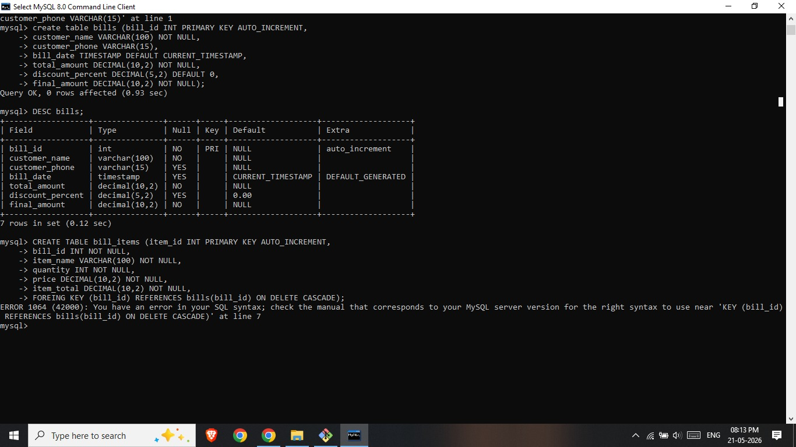

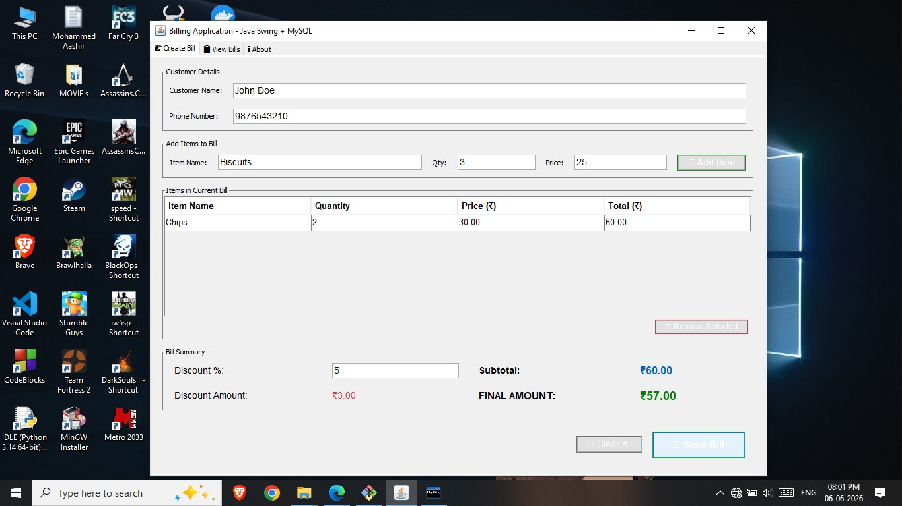
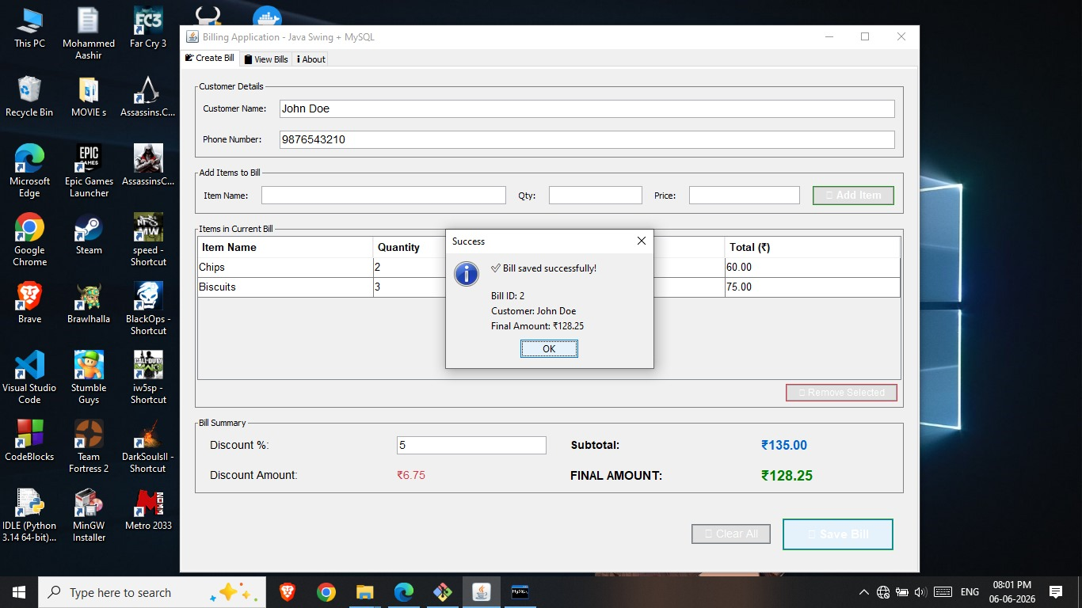
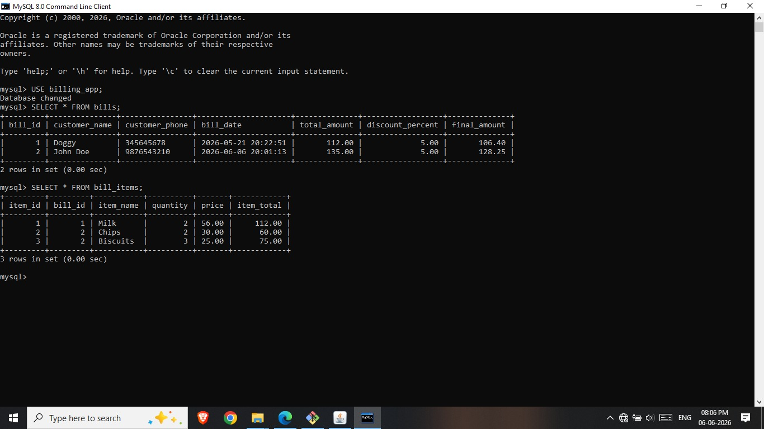

CHAPTER-6

CONCLUSION

The Smart Billing System successfully replaces manual billing with a fast, accurate, and easy-to-use Java application. It is designed so that any shop can adopt it with minimal staff training.
- Goal Achievement: The system successfully achieved all primary project goals, including accurate billing, automated inventory, and comprehensive reports.
- Technical Implementation: Advanced Java skills such as JDBC, Swing, Object-Oriented Programming (OOP), and exception handling were used effectively to build a robust architecture.
- Practical Application: The resulting software is highly practical and can be deployed in real retail shops immediately.
- Data Security: The application includes built-in security features that protect sensitive business data using role-based access and encryption.
- Business Value: Beyond basic billing, the system provides valuable business insights through the generation of daily and monthly sales reports.

REFERENCES
• Herbert Schildt, "Java: The Complete Reference", 12th Edition, McGraw-Hill, 2021.
• Kathy Sierra & Bert Bates, "Head First Java", 3rd Edition, O'Reilly Media, 2022.
• Oracle Corporation, "Java SE Documentation & JDBC API Guide", docs.oracle.com/javase.
• MySQL Official Documentation, "MySQL 8.0 Reference Manual", dev.mysql.com/doc.
• Paul Deitel & Harvey Deitel, "Java How to Program", 11th Edition, Pearson, 2018.
Github Link: https://github.com/mdaashir10/Billing_app_project
If your project report includes a section outlining the Waterfall method, system analysis, requirements gathering, or UML diagrams (Use Case, ER diagrams):

